Question 5

Overall, customers who made first purchases during the holiday season show distinct purchasing behaviors from customers who only purchase outside of the holiday season. For the sake of readability, customers who made a first purchase during the holiday season will be referred to as holiday purchasers versus their non-holiday purchaser counterpoints.

Looking at the distribution of transaction spend by holiday versus non-holiday purchasers, non-holiday purchasers tend to spend 92$ more than their holiday shopper counterparts.

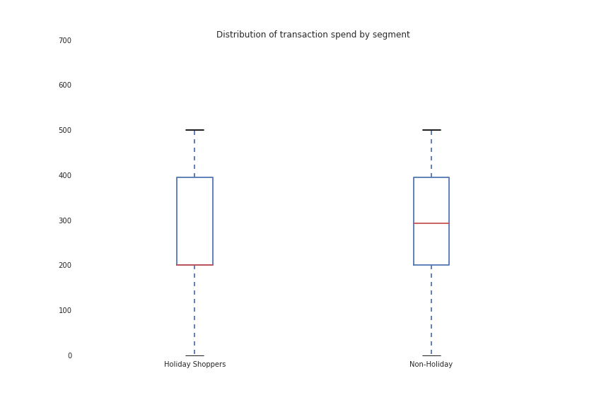

After correcting for outliers, first time holiday shoppers on average made 1.5 more purchases than their non-holiday counterparts.

|  |  |  |
| --- | --- | --- |
|  | **Non-Holiday** | **Holiday** |
| **Count** | 3225 | 4086 |
| **Mean** | 3.492403 | 5.102790 |
| **Std** | 3.926356 | 5.595741 |
| **Min** | 1 | 1 |
| **25%** | 1 | 2 |
| **50%** | 2 | 3 |
| **75%** | 4 | 6 |
| **Max** | 63 | 72 |

The largest purchasing difference was driven by the definition of the groups and can be seen in the quarter with which holiday versus non holiday shoppers purchased. Holiday shopper activity is concentrated around Q4 while by definition the non-holiday shoppers outpaced the holiday shoppers in all other quarters.

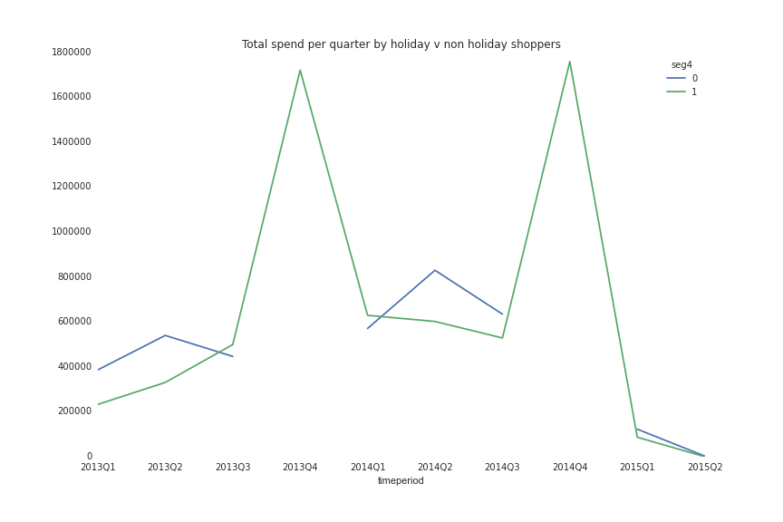

Holiday shoppers used 3 channels fairly evenly (distribution partners, holographic commerce, and retail) while non-holiday shoppers favored holographic commerce by a wide margin.

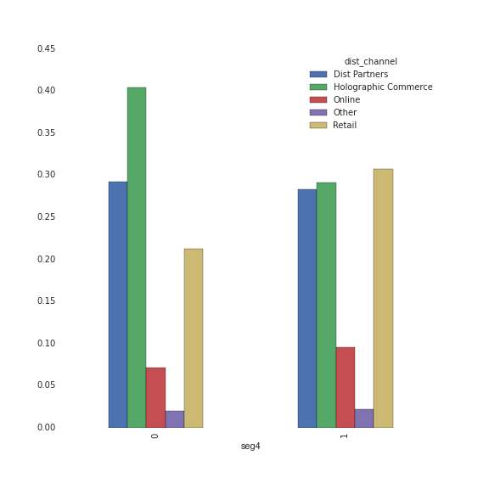

Non-holiday shoppers mainly used flagship stores while holiday shoppers used the other dealers.

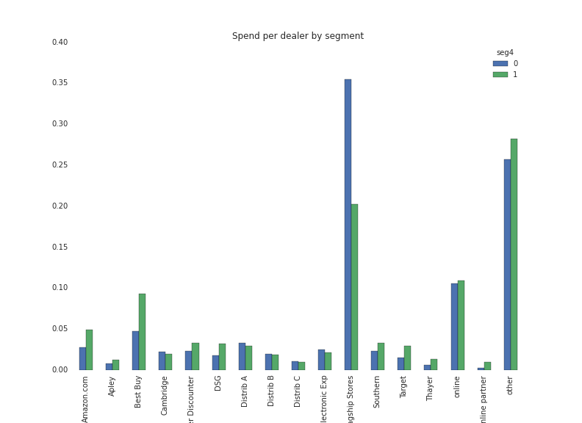

Coupon usage is small for both holiday and non-holiday shoppers but holiday shoppers were almost twice as prevalent when using coupons.

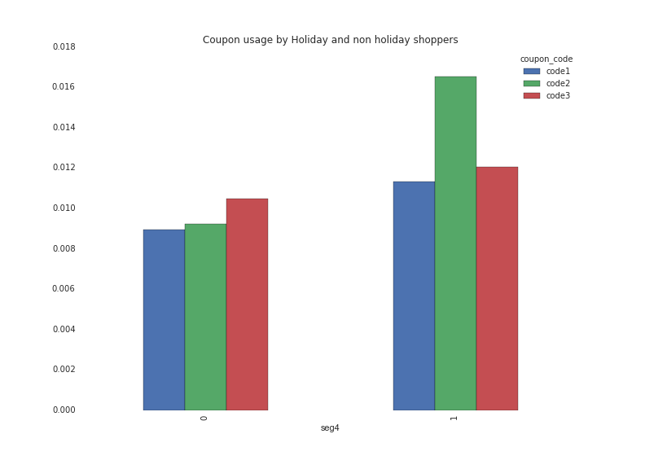

The product profile of holiday shoppers differs from non-holiday shoppers though both tended to favor Status Indicator Sm.

